[Matt Grossmann](https://t.co/D7uIwMY83T" \t "_blank) noted the close relationship between  
the amount of news coverage candidates in the Democratic primary have been  
receiving and their polling numbers.

Presidential candidate poll standing & prior week cable TV news share are correlated at .9

Harris got a bump in news coverage after the 1st debate that faded with her polls; Warren's news coverage rose relative to Sanders with her polls; Biden leads both weekly [pic.twitter.com/Z5njfyYdJg](https://t.co/Z5njfyYdJg)

— Matt Grossmann (@MattGrossmann) [September 27, 2019](https://twitter.com/MattGrossmann/status/1177635234713501696?ref_src=twsrc%5Etfw)

This got me thinking about what the available data can bring to bear on this  
question. I have ongoing interest in longitudinal data and the  
[software for analyzing it](https://jacob-long.com/post/panelr-intro/), so this seemed like a fun,  
quick project. Luckily, there are several great resources to take the pain out  
of data collection in this case.

The GDELT project  
[offers a TV API](https://blog.gdeltproject.org/gdelt-2-0-television-api-debuts/)  
that allows anyone to look at how much cable news channels mention the  
candidates (specifically, the number of 15-second windows of coverage that  
mention the candidate by name). [Media Cloud](https://mediacloud.org/) also  
lets you look at how often candidates are mentioned in online news articles.  
Helpfully, the fine folks at FiveThirtyEight have  
[compiled these data](https://github.com/fivethirtyeight/data/tree/master/media-mentions-2020)  
as well as polls, already.

Now I’m going to walk through how to get these data into R. Skip to the  
analysis by clicking [here](http://feedproxy.google.com/~r/JacobLongR/~3/6yu4VM5m5jA/#analysis).

**Getting the data**

As mentioned, FiveThirtyEight has compiled most of the data we’re interested in,  
albeit in different places. We will read them into R as separate data frames and  
join them later. There are some warnings from the CSV parser but they aren’t  
important for our purposes.

library(tidyverse)

library(jtools)

library(tsibble)

cable\_mentions <- read\_csv("<https://github.com/fivethirtyeight/data/raw/master/media-mentions-2020/cable_weekly.csv>")

online\_mentions <- read\_csv("<https://github.com/fivethirtyeight/data/raw/master/media-mentions-2020/online_weekly.csv>")

# Immediately convert `end\_date` to date class

polls <- read\_csv("<https://projects.fivethirtyeight.com/polls-page/president_primary_polls.csv>")

Now we have the data, but we still have to get it in shape. First, we deal with  
the polls.

**Polls**

These data are formatted such that every row is a unique combination  
of candidate and poll. So if a poll included 20 candidates, there would be 20  
rows to cover the results of that single poll. This is actually a good thing  
for our purposes.

I first create two vectors of candidate names. The first is the  
candidates who will be retained for analysis, in the format they are named in  
the polling data. The second is the same set of candidates, but with their less  
formal names that are used in the media data.

candidates <- c("Amy Klobuchar", "Andrew Yang", "Bernard Sanders",

"Beto O'Rourke", "Bill de Blasio", "Cory A. Booker",

"Elizabeth Warren", "Eric Swalwell", "Jay Robert Inslee",

"Joe Sestak", "John Hickenlooper", "John K. Delaney",

"Joseph R. Biden Jr.", "Julián Castro", "Kamala D. Harris",

"Kirsten E. Gillibrand", "Marianne Williamson",

"Michael F. Bennet", "Pete Buttigieg", "Seth Moulton",

"Steve Bullock", "Tim Ryan", "Tom Steyer", "Tulsi Gabbard",

"Wayne Messam")

candidates\_clean <- c("Amy Klobuchar", "Andrew Yang", "Bernie Sanders",

"Beto O'Rourke", "Bill de Blasio", "Cory Booker",

"Elizabeth Warren", "Eric Swalwell", "Jay Inslee",

"Joe Sestak", "John Hickenlooper", "John Delaney",

"Joe Biden", "Julian Castro", "Kamala Harris",

"Kirsten Gillibrand", "Marianne Williamson",

"Michael Bennet", "Pete Buttigieg", "Seth Moulton",

"Steve Bullock", "Tim Ryan", "Tom Steyer",

"Tulsi Gabbard", "Wayne Messam")

Now we do some filtering and data cleaning for polls. See the inline comments  
for some explanations, but basically we’re using only polls of known quality,  
that cover the time period for which we have media data, and only national  
polls.

polls <- polls %>%

# Convert date to date format

mutate(end\_date = as.Date(end\_date, format = "%m/%d/%y")) %>%

filter(

# include only polls of at least modest quality

fte\_grade %in% c("C-", "C", "C+", "B-", "B", "B+", "A-", "A", "A+"),

# only include polls ending on or after 12/30/2018

end\_date >= as.Date("12/30/2018", "%m/%d/%Y"),

# only include \*Democratic\* primary polls

party == "DEM",

# only include the selected candidates

candidate\_name %in% candidates,

# only national polls

[is.na](http://is.na)(state),

# Exclude some head-to-head results, etc.

notes %nin% c("head-to-head poll",

"HarrisX/SR Democrat LV, definite voter",

"open-ended question")

) %>%

mutate(

# Have to add 1 to the date to accommodate tsibble's yearweek()

# starting on Monday rather than Sunday like our other data sources

week = as.Date(yearweek(end\_date + 1)) - 1,

# Convert candidate names to factor so I can relabel them

candidate\_name = factor(candidate\_name, levels = candidates, labels = candidates\_clean)

)

Now we aggregate by week, forming a weekly polling average by candidate. If we  
were trying to build a forecast, we would do this in a better way that wouldn’t  
have so much variation. For now, all I do is weight the results by  
(logged) sample size. Note that pct refers to the percentage of the “votes”  
the candidate received in the poll.

polls\_agg <- polls %>%

group\_by(week, candidate\_name) %>%

summarize(

pct\_polls = weighted.mean(pct, log(sample\_size))

)

For a quick sanity check, let’s plot these data to see if things line up (  
I omit the relatively lower-polling candidates for simplicity).

library(ggplot2)

top\_candidates <- c("Joe Biden", "Elizabeth Warren", "Bernie Sanders",

"Pete Buttigieg", "Kamala Harris", "Beto O'Rourke",

"Cory Booker")

ggplot(filter(polls\_agg, candidate\_name %in% top\_candidates),

aes(x = week, y = pct\_polls, color = candidate\_name)) +

geom\_line() +

theme\_nice()

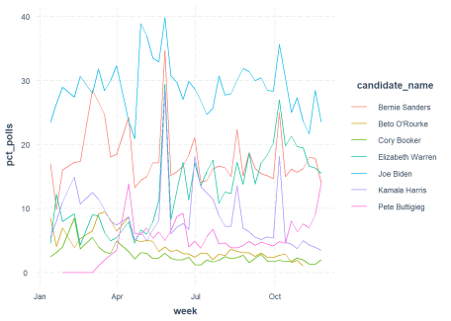

Okay, it’s a bit more variable than  
[other](https://projects.economist.com/democratic-primaries-2020/)  
[aggregators](https://www.nytimes.com/interactive/2020/us/elections/democratic-polls.html)  
but it’s showing us the same basic trends.

**Media**

We have two data frames with media coverage info, cable\_mentions and  
online\_mentions. These are in much better shape to begin with, but we do need  
to combine them and make a couple changes. Each row in these data represent  
a candidate and week, so there are $weeks \times candidates$ rows.

This is a good example of a time  
to use an inner join. Note that our key variables are the proportion of  
all news clips/articles that mention any candidate that mention the candidate  
in question. In other words, we’re ignoring variation in how much the primary  
gets discussed in the news and instead focusing on how big each candidate’s  
share of the coverage is.

media <-

inner\_join(cable\_mentions, online\_mentions, by = c("date", "name")) %>%

mutate(

# Create new variables that put the media coverage variables on

# same scale as poll numbers

pct\_cable = 100 \* pct\_of\_all\_candidate\_clips,

pct\_online = 100 \* pct\_of\_all\_candidate\_stories

)

Let’s look at the trends for cable news…

library(ggplot2)

top\_candidates <- c("Joe Biden", "Elizabeth Warren", "Bernie Sanders",

"Pete Buttigieg", "Kamala Harris", "Beto O'Rourke",

"Cory Booker")

ggplot(filter(media, name %in% top\_candidates),

aes(x = date, y = pct\_cable, color = name)) +

geom\_line() +

theme\_nice()

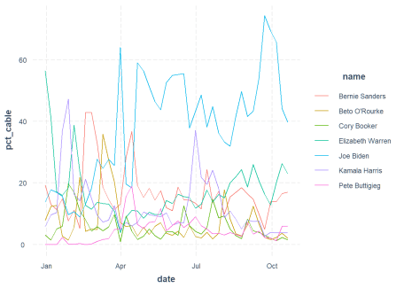

This looks a bit similar to the polling trends, although more variable over  
time.

And now online news…

library(ggplot2)

top\_candidates <- c("Joe Biden", "Elizabeth Warren", "Bernie Sanders",

"Pete Buttigieg", "Kamala Harris", "Beto O'Rourke",

"Cory Booker")

ggplot(filter(media, name %in% top\_candidates),

aes(x = date, y = pct\_online, color = name)) +

geom\_line() +

theme\_nice()

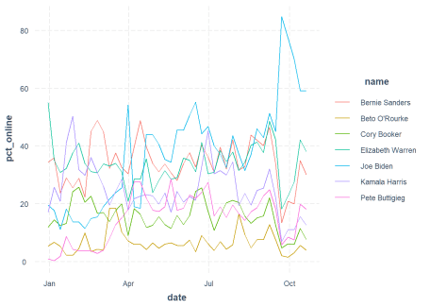

This one’s a bit more all over the place, with the minor candidates espcially  
having higher highs.

**Combine data**

Now we just need to get all this information in the same place for analysis.  
More inner joins!

joined <- inner\_join(polls\_agg, media,

by = c("candidate\_name" = "name", "week" = "date"))

Now we have everything in a single data frame where each row represents one  
week and one candidate. To make things work for statistical analysis, I’m going  
to do a couple conversions — one to the panel\_data format, from my  
panelr package, and another to pdata.frame format, from the plm package.  
We’ll be using both packages for analysis.

library(panelr)

# panel\_data needs a number or ordered factor as wave variable

joined$wave <- as.ordered(joined$week)

joined\_panel <- panel\_data(ungroup(joined), id = candidate\_name, wave = wave)

joined\_pdata <- as\_pdata.frame(joined\_panel)

**Analysis**

Okay, so we have multiple time series for each candidate: their status in the  
polls, how much of the cable news coverage they’re getting, and how  
much of the online news coverage they’re getting. We’d like to know whether  
any of these are causing the others. Most interesting is whether the news  
coverage drives better results in the polls.

The kind of analyses we can do all have in common the idea of comparing each  
candidate to himself or herself in the past. If Elizabeth Warren’s share of  
news coverage goes from 10% to 12%, up 2 percentage points, where do we expect  
her share in the polls to go? If it goes from 15% to 17%, then it goes up 2  
percentage points as well. This is treated equivalently to if Andrew Yang goes  
from 0% of news to 2% of news and then sees his polls goes from 1% to 3%.

Of course, this still doesn’t sort out the problem of reverse causality. If we  
see that news coverage and polls change at the same time, it’s not obvious  
which caused the other (and we’ll ignore the possibility that something else  
caused both for the time being). There are several methods for dealing with  
this and I’ll focus on ones that use past values of polls to predict future  
ones.

**Fixed effects models**

Fixed effects models are a common way to remove the influence of certain kinds  
of confounding variables, like a candidate’s pre-existing popularity. It  
doesn’t fix the problem of confounders that change over time (like a change in  
the candidate’s campaign strategy or a new scandal), but it’s a workhorse  
model for longitudinal data.

The process we’re looking at is *dynamic*, meaning candidates’ support  
in the past affects the present; people don’t pick their favorite candidate  
every week, they have a favorite candidate who will remain in that position  
unless something changes. We model this statistically by using last week’s  
polling average as a predictor of this week’s polling average.  
In the panel data literature, using so-called fixed effects models with a  
lagged value of the dependent variable in the model is a big no-no. This is  
because something called  
[Nickell bias](https://www.jstor.org/stable/1911408?seq=1#page_scan_tab_contents),  
which basically means that models like this give you wrong results in a  
predictable way.

Luckily, these data are not quite the same as the kind that the Nickell bias  
affects the most. We have 24 candidates with up to 38 weeks of data for each.  
The Nickell bias tends to be most problematic when you have relatively few  
time points and relatively many people (in this case candidates). So we’ll  
start with fixed effects models and assume the Nickell bias isn’t too serious.

I’m going to use the wbm() function from my panelr package to do this  
analysis.

fix\_mod <- wbm(pct\_polls ~ lag(pct\_polls) +

pct\_cable + lag(pct\_cable) +

pct\_online + lag(pct\_online),

data = joined\_panel, model = "fixed")

summary(fix\_mod)

MODEL INFO:

Entities: 24

Time periods: 2019-01-13-2019-09-15

Dependent variable: pct\_polls

Model type: Linear mixed effects

Specification: within

MODEL FIT:

AIC = 2233.15, BIC = 2269.64

Pseudo-R² (fixed effects) = 0.03

Pseudo-R² (total) = 0.98

Entity ICC = 0.98

-------------------------------------------------------------

Est. S.E. t val. d.f. p

--------------------- ------- ------ -------- -------- ------

(Intercept) 3.85 1.45 2.65 23.01 0.01

lag(pct\_polls) 0.64 0.03 24.74 678.01 0.00

pct\_cable 0.08 0.01 6.29 678.01 0.00

lag(pct\_cable) 0.05 0.01 4.05 678.01 0.00

pct\_online -0.03 0.01 -2.29 678.01 0.02

lag(pct\_online) -0.02 0.01 -1.39 678.01 0.17

-------------------------------------------------------------

p values calculated using Satterthwaite d.f.

RANDOM EFFECTS:

------------------------------------------

Group Parameter Std. Dev.

---------------- ------------- -----------

candidate\_name (Intercept) 7.108

Residual 1.007

------------------------------------------

Here’s what the output is saying:

* First of all, there’s evidence of momentum. If your poll numbers went up  
  last week, all else being equal they’ll probably be up this week too.
* Gains in cable news coverage both this week and last week are associated with  
  gains in the polls this week.
* Gains in online news coverage this week are associated (very weakly) with  
  declines in the polls this week, assuming no change in cable news coverage.

I will note that as far as the online coverage is concerned, if I drop cable  
news coverage from the model then suddenly online coverage appears to have a  
positive effect. I think what’s going on there is both online and cable news  
cover candidates in a way that helps them, but online coverage is sometimes  
harmful in a way that is not true of online coverage. Either that or there’s  
just a lot more noise in the online data.

**Adjusting for trends**

This was the simplest analysis I can do. I can also try to remove any trends  
in the data to try to account for something that isn’t in the model that drives  
some candidates up or down over time. Basically, for each candidate we subtract  
their over-time trend from each week’s polling numbers and news coverage and see  
if deviations *from their trend* predict each other.

The risk with this approach is that  
it really is news that has most of the influence and you’re modeling away  
some of the “real” effects along with the stuff you don’t want around.

fix\_mod <- wbm(pct\_polls ~ lag(pct\_polls) +

pct\_cable + lag(pct\_cable) +

pct\_online + lag(pct\_online),

data = joined\_panel, model = "fixed",

detrend = TRUE)

summary(fix\_mod)

MODEL INFO:

Entities: 24

Time periods: 2019-01-13-2019-09-15

Dependent variable: pct\_polls

Model type: Linear mixed effects

Specification: within

MODEL FIT:

AIC = 2169.99, BIC = 2206.48

Pseudo-R² (fixed effects) = 0.91

Pseudo-R² (total) = 0.97

Entity ICC = 0.7

-------------------------------------------------------------

Est. S.E. t val. d.f. p

--------------------- ------- ------ -------- -------- ------

(Intercept) 1.01 0.34 2.95 16.39 0.01

lag(pct\_polls) 0.69 0.02 29.60 339.36 0.00

pct\_cable 0.08 0.01 6.43 683.75 0.00

lag(pct\_cable) 0.04 0.01 3.52 688.28 0.00

pct\_online -0.03 0.01 -2.11 692.90 0.04

lag(pct\_online) -0.01 0.01 -1.00 690.93 0.32

-------------------------------------------------------------

p values calculated using Satterthwaite d.f.

RANDOM EFFECTS:

------------------------------------------

Group Parameter Std. Dev.

---------------- ------------- -----------

candidate\_name (Intercept) 1.559

Residual 1.012

------------------------------------------

Okay, same story here. Some good evidence of cable news helping and some very  
weak evidence of online news possibly hurting.

**Driven by minor candidates?**

Responding to Grossmann’s tweet, Jonathan Ladd raises an interesting question:

I wonder how much of this is driven only by the non-Biden candidates, since it seems to show that much of poll movement is driven by name recognition and need to coordinate on a non-Biden alternative.

— Jonathan Ladd (@jonmladd) [September 28, 2019](https://twitter.com/jonmladd/status/1177912481517309952?ref_src=twsrc%5Etfw)

There are a couple of ways to look at this. First of all, let’s think about  
this as less of a Biden vs. all others phenomenon and more about whether this  
effect of news on candidate support is concentrated among those with relatively  
low support.

We can deal with this via an interaction effect, seeing whether the effects  
are stronger or weaker among candidates with higher/lower absolute levels of  
support. I need to fit a slightly different model here to accommodate the  
inclusion of the lagged dependent variable without subtracting its mean (as is  
done for the conventional fixed effects analysis). Our focus will be on the  
“within” effects and cross-level interactions in the output below.

int\_mod <- wbm(pct\_polls ~

pct\_cable + lag(pct\_cable) +

pct\_online + lag(pct\_online) | lag(pct\_polls) |

lag(pct\_polls) \* pct\_cable +

lag(pct\_polls) \* lag(pct\_cable) +

lag(pct\_polls) \* pct\_online +

lag(pct\_polls) \* lag(pct\_online),

data = joined\_panel, model = "w-b")

summary(int\_mod)

MODEL INFO:

Entities: 24

Time periods: 2019-01-13-2019-09-15

Dependent variable: pct\_polls

Model type: Linear mixed effects

Specification: within-between

MODEL FIT:

AIC = 2109.28, BIC = 2173.14

Pseudo-R² (fixed effects) = 0.98

Pseudo-R² (total) = 0.98

Entity ICC = 0.21

WITHIN EFFECTS:

-------------------------------------------------------------

Est. S.E. t val. d.f. p

--------------------- ------- ------ -------- -------- ------

pct\_cable 0.09 0.02 4.68 672.05 0.00

lag(pct\_cable) 0.02 0.02 1.20 671.39 0.23

pct\_online -0.01 0.02 -0.54 673.16 0.59

lag(pct\_online) 0.04 0.02 2.55 672.97 0.01

-------------------------------------------------------------

BETWEEN EFFECTS:

---------------------------------------------------------------

Est. S.E. t val. d.f. p

----------------------- ------- ------ -------- -------- ------

(Intercept) -0.16 0.17 -0.92 18.51 0.37

imean(pct\_cable) 0.31 0.03 9.27 38.40 0.00

imean(pct\_online) 0.00 0.02 0.03 17.29 0.98

lag(pct\_polls) 0.63 0.02 26.58 589.12 0.00

---------------------------------------------------------------

CROSS-LEVEL INTERACTIONS:

----------------------------------------------------------------------------

Est. S.E. t val. d.f. p

------------------------------------ ------- ------ -------- -------- ------

pct\_cable:lag(pct\_polls) 0.00 0.00 0.43 671.50 0.67

lag(pct\_cable):lag(pct\_polls) 0.00 0.00 4.05 674.01 0.00

pct\_online:lag(pct\_polls) -0.00 0.00 -2.20 671.51 0.03

lag(pct\_online):lag(pct\_polls) -0.01 0.00 -5.66 674.15 0.00

----------------------------------------------------------------------------

p values calculated using Satterthwaite d.f.

RANDOM EFFECTS:

------------------------------------------

Group Parameter Std. Dev.

---------------- ------------- -----------

candidate\_name (Intercept) 0.4972

Residual 0.955

------------------------------------------

Okay so there’s a lot going on here. First of all, we see that the instantaneous  
effect of changes in cable news coverage does not appear to depend on the  
candidate’s previous standing in the polls. For the other interaction terms,  
we have some evidence of the effects changing depending on the candidate’s  
standing in the polls.

Let’s examine them one by one, with help from  
my interactions package. I’ll show predicted values of poll numbers depending  
on different values of news coverage to give a gist of what’s going on.

**Last week’s cable news coverage**

Each line represents the predicted standing in this week’s polls at different  
levels of last week’s standing in the polls. What we really care about is the  
*slope* of the lines.

library(interactions)

interact\_plot(int\_mod, `lag(pct\_cable)`, `lag(pct\_polls)`,

modx.values = c(2, 10, 20),

x.label = "Last week's % change in cable news coverage",

y.label = "This week's polling average",

legend.main = "Last week's polling average")

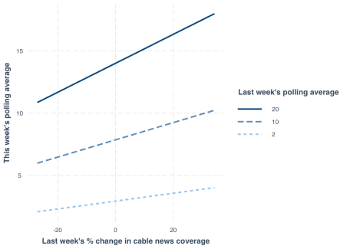

So what we see here is that the *higher* a candidate’s standing in the polls,  
the *more* they benefit from news coverage! This stands somewhat in  
contradiction to Ladd’s speculation. Another way to think about it is that  
these changes in news coverage tend to have more staying power for candidates  
with more support.

**Last week’s online coverage**

For last week’s online coverage, we see in the model output that for a candidate  
with hypothetical zero polling support, increases in online news coverage are  
good for future polling, but there’s a negative interaction term. Let’s look  
at how that plays out.

interact\_plot(int\_mod, `lag(pct\_online)`, `lag(pct\_polls)`,

modx.values = c(2, 10, 20),

x.label = "Last week's % change in online news coverage",

y.label = "This week's polling average",

legend.main = "Last week's polling average")

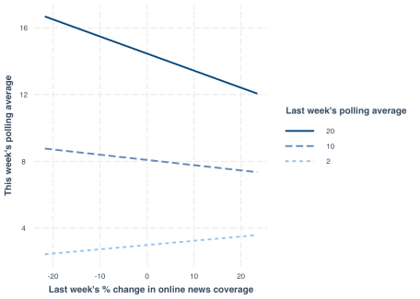

Here we see that for higher polling candidates, the lagged changes in  
online coverage are a detriment while for lower polling candidates, such changes  
are a much-needed (small) boost.

**This week’s online coverage**

Let’s do the same test with the effect of this week’s online coverage on  
this week’s polls.

interact\_plot(int\_mod, pct\_online, `lag(pct\_polls)`,

modx.values = c(2, 10, 20),

x.label = "This week's % change in online news coverage",

y.label = "This week's polling average",

legend.main = "Last week's polling average")

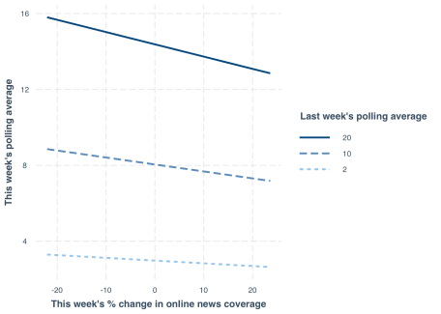

Quite similar to last week’s online coverage, except not even the low-polling  
candidates seem to benefit.

**Just drop Biden from the analysis**

Another thing we can do is just drop Biden, who for most of the campaign cycle  
has dominated the polls and news coverage.

no\_biden <- wbm(pct\_polls ~ lag(pct\_polls) +

pct\_cable + lag(pct\_cable) +

pct\_online + lag(pct\_online),

data = filter(joined\_panel, candidate\_name != "Joe Biden"),

model = "fixed")

summary(no\_biden)

MODEL INFO:

Entities: 23

Time periods: 2019-01-13-2019-09-15

Dependent variable: pct\_polls

Model type: Linear mixed effects

Specification: within

MODEL FIT:

AIC = 1879.42, BIC = 1915.49

Pseudo-R² (fixed effects) = 0.07

Pseudo-R² (total) = 0.97

Entity ICC = 0.96

-------------------------------------------------------------

Est. S.E. t val. d.f. p

--------------------- ------- ------ -------- -------- ------

(Intercept) 2.70 0.92 2.93 22.01 0.01

lag(pct\_polls) 0.65 0.02 26.80 643.01 0.00

pct\_cable 0.10 0.01 7.91 643.02 0.00

lag(pct\_cable) 0.04 0.01 2.98 643.01 0.00

pct\_online -0.02 0.01 -1.92 643.02 0.05

lag(pct\_online) 0.01 0.01 1.30 643.01 0.20

-------------------------------------------------------------

p values calculated using Satterthwaite d.f.

RANDOM EFFECTS:

------------------------------------------

Group Parameter Std. Dev.

---------------- ------------- -----------

candidate\_name (Intercept) 4.414

Residual 0.8483

------------------------------------------

And in this case, the results are basically the same, although the benefits of  
news coverage are perhaps a bit stronger.

**A more advanced model**

Let’s push a bit further to make sure we’re not making a mistake on the basic  
claim that (cable) news coverage appears to be beneficial. A more robust  
approach is to use an analysis that more deliberately addresses these issues  
of reverse causality and endogeneity.

Normally, I’d reach for the dynamic panel  
models featured in my dpm package, but these can’t handle data with so many  
time points and so few people. Instead, I’ll use the  
[Arellano-Bond estimator](https://en.wikipedia.org/wiki/Arellano%E2%80%93Bond_estimator)[1](http://feedproxy.google.com/~r/JacobLongR/~3/6yu4VM5m5jA/#fn:blundell),  
which the models in dpm were meant to replace — they are both unbiased,  
but Arellano-Bond models tend to be inefficient. In other words, this method  
is more conservative.

For this, I need the plm package and its pgmm() function. I’ll skip the  
technicalities and just say the interpretations will be similar to what I just  
did, but the underlying algorithm is more rigorous at ruling out reverse  
causality.

library(plm)

ab\_mod <- pgmm(pct\_polls ~ lag(pct\_polls, 1) +

pct\_cable + lag(pct\_cable) +

pct\_online + lag(pct\_online) |

lag(pct\_polls, 2:15),

data = joined\_pdata, effect = "individual", model = "twosteps",

transformation = "ld")

summary(ab\_mod)

Oneway (individual) effect Two steps model

Call:

pgmm(formula = pct\_polls ~ lag(pct\_polls, 1) + pct\_cable + lag(pct\_cable) +

pct\_online + lag(pct\_online) | lag(pct\_polls, 2:15), data = joined\_pdata,

effect = "individual", model = "twosteps", transformation = "ld")

Unbalanced Panel: n = 24, T = 11-37, N = 731

Number of Observations Used: 1361

Residuals:

Min. 1st Qu. Median Mean 3rd Qu. Max.

-11.44106 -0.27460 0.00000 -0.00144 0.25889 9.50637

Coefficients:

Estimate Std. Error z-value Pr(>|z|)

lag(pct\_polls, 1) 0.8953903 0.0196164 45.6449 < 2.2e-16 \*\*\*

pct\_cable 0.0741411 0.0165264 4.4862 7.25e-06 \*\*\*

lag(pct\_cable) 0.0109705 0.0065706 1.6696 0.09499 .

pct\_online -0.0108026 0.0120645 -0.8954 0.37057

lag(pct\_online) 0.0095829 0.0140126 0.6839 0.49405

---

Signif. codes: 0 '\*\*\*' 0.001 '\*\*' 0.01 '\*' 0.05 '.' 0.1 ' ' 1

Sargan test: chisq(437) = 18.55703 (p-value = 1)

Autocorrelation test (1): normal = -2.282824 (p-value = 0.022441)

Autocorrelation test (2): normal = -1.182395 (p-value = 0.23705)

Wald test for coefficients: chisq(5) = 146865.5 (p-value = < 2.22e-16)

Okay so what does this all mean? Basically, the same story we saw with the  
other, simpler analyses.

**Conclusions**

Does news coverage help candidates in the Democratic primary race? Probably.  
There are some limitations of the analyses at hand. It is possible, for  
instance, that there is something else that changes the news coverage. In fact,  
that is likely — early on, it appeared Elizabeth Warren drove news coverage  
by releasing new policy proposals on a fairly frequent schedule. Did the  
policy proposals themselves boost her support rather than the news coverage of  
them? That’s hard to separate, especially given the kind of birds-eye view  
we’re taking here. We’re not saying what’s in the news coverage.

Matt Grossmann suggested sentiment analysis:

Warren has had more TV coverage than Sanders over the last 7 weeks. Anecdotally, it seems to have been much more positive media coverage than for Biden & Sanders, enabling her rise. Is anyone doing real-time media sentiment analysis?

— Matt Grossmann (@MattGrossmann) [September 28, 2019](https://twitter.com/MattGrossmann/status/1177911349382393856?ref_src=twsrc%5Etfw)

and that’s probably a wise choice. Maybe once I’m off the job market!